APPLICATION INSTRUCTIONS

Pierce College’s Bachelor of Applied Science in Teaching application is now online! This is a big step in creating an application process that is accessible for all prospective students; however, once you begin your online application, you are unable to save your progress and return at a later time. This document serves as a guide to help you prepare to complete and submit your application in one sitting. Included are the prompts for required essay/written response submissions as well as descriptions for other information to be included in your application.

If you have any questions or concerns regarding the online application format or its contents, please contact the Pierce College Education department at Teaching@pierce.ctc.edu.

Pierce Student ID

Enter your ctcLink ID number (9 characters, no dashes/hyphens/spaces, etc.). This number would have been provided to you at the time your application to Pierce College was completed and submitted.
NOTE: If you have a ctcLink ID number from your time at another Washington State community-technical college, you must still apply for admission to Pierce College.

If you do not already have a ctcLink ID number, please apply to Pierce College online. Once you finish the Pierce College online application, you will be given a ctcLink ID number. Enter the ctcLink ID number in the BAS-T application to continue.

Accreditation and Application Requirements

You will be asked to confirm that you understand the statement provided regarding Pierce College’s Bachelors of Applied Science in Teaching accreditation in Washington State. You will also be asked to confirm understanding of the program admission requirements and application deadlines.

Applicant Information

Have your personal information ready and available to include in this section. Personal information includes: your name, address, personal email address, phone number, date of birth, student status, and cohort (part-time vs. full-time) you are planning to apply for. For more information regarding the differences between cohorts and the details of each, visit the BAS-T Cohort Options webpage.
Educational History

Be prepared to answer all questions related to your college enrollment history, including the courses you have taken that meet application requirements and the names of all colleges attended.
NOTE: Be sure to list all colleges attended regardless of whether you earned a degree from that institution or not. All enrollment history must be verified by transcript.

Official Transcripts

Please submit official transcripts from all institutions previously attended (excluding Pierce College). You can do so by requesting electronic transcripts be submitted to Pierce College through Parchment (if the institution participates with that service), by email to Evaluations@pierce.ctc.edu, or by requesting official transcripts be mailed in original sealed envelopes to: Pierce College Evaluations Office, 9401 Farwest Drive SW, Lakewood WA 98498. For more information, visit our Evaluations webpage.
NOTE: Transcripts that are in any way handled by the student, even if they were sent to the student as official transcripts, are considered unofficial; for transcripts to be considered official, they must be sent to Pierce College directly from the institution.

WEST-B, SAT, or ACT Scores

Washington State Administrative Code (WAC) requires that all students enrolled in Teacher Preparation Programs attempt the three West-B tests (Reading, Writing and Math) or the Reading, Writing and Math sections of the SAT or ACT test. Please indicate how you have met this requirement for each subject area on your application, including the test you took for each subject area, the score you received, the date of the test, and an upload of the test results for each test type. For any tests you have not completed, please list the anticipated test date. For more information, visit our BAS-T Testing webpage.

Professional Recommendations

Applicants must submit three (3) professional recommendations, which are to be completed through SurveyMonkey. Two (2) of the three (3) recommenders should be from current supervisors or others who have formally evaluated your work, and one (1) of the three recommenders can be an academic reference. Please be sure to notify recommenders that you have listed them as a reference and that they will be receiving a SurveyMonkey link to complete at their earliest convenience.
NOTE: BAS-T program staff will send the recommendation link to recommenders directly.

Employment and/or Volunteer History

List all employment and volunteer experience working with children, birth through third-grade. For each position, include the position title, organization/place of employment, the dates of employment, and the age groups taught. This section has fields to input the past five positions you’ve held working with children. Please be sure to prioritize your most recent experiences.
Resume

In this section, applicants will be asked if they are currently employed in the Washington State school system as an instructional paraprofessional, paraeducator, or substitute and, if so, requests that they list the school district(s) through which they are employed. Then, students must upload a copy of their resume to the application. Resume file submissions should be in either PDF or .docx file format.

Personal Essay

The following prompt is given for the personal essay component of the BAS-T application:
Our program has, at its heart, a core theme of equity, diversity, and inclusion (EDI). The program’s guiding framework is Pedagogical Content Knowing, which was developed by Cochran, DeRuiter, & King (1993):

A Development Model of Pedagogical Content Knowing (PCKg)

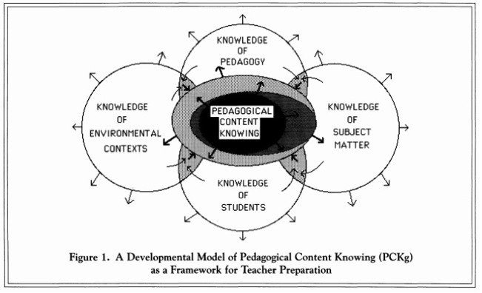
as a Framework for Teacher Preparation

Please respond to the following questions in your essay:
- Why are you drawn to teaching young children? You can include personal and professional experiences.
- This program emphasizes the following five areas. What are your strengths in each of these five areas?
  - Equity, diversity, and inclusion
  - The subject matter (math, English, science, social studies, art, music, and health)
  - Pedagogy (how to teach/the art and science of teaching)
  - Environmental contexts (communities, neighborhoods, schools)
  - Knowledge of students (students as unique individuals)
The section provides an opportunity to upload a personal essay file. It is encouraged that you write your response in a word processor (Microsoft Word, etc.) and utilize editing tools such as Spell Check, Grammar Check, etc. as well as the Word Count function to ensure your response is 500 words or less. Personal essay file submissions should be in either PDF or .docx file format.

Response to Parent Email

Please respond to one of the following parent’s email messages as if you were their child’s teacher. You only need to respond to either A or B.
The following prompts are given for the parent email response component of the BAS-T application:
Email A:
Hello,
I am the parent of Alisson. I am emailing you in regards to the activity that Aly brought home this week. It was a coloring worksheet with pilgrims and Indians. Also, there was a craft done where students made a feather headband, pilgrim hats, and the Mayflower. As you may not be aware of, our family is of Native American heritage and are Puyallup tribal members. It is very disturbing to me to hear how you have taught the children about Thanksgiving, pilgrims, and Indians in your class this week. You addressed my family’s heritage in the past tense. We are still here! Please tell your plan to deal with situation.
Email B:
Hello,
My name is Lorinda Johnson and I am the parent of DaMarcus Johnson. I am emailing you about an incident that happened on the playground that Damarcus shared with me last night when he came home. Children were asking Damarcus how it felt to be a slave and asking him if he was beaten as a Black person. Damarcus shared that lately, as one of the few children of color in the school, he has been feeling very isolated and targeted amongst his classmates. It seems to me that this situation keeps getting ignored by staff. How are you going to support him and make this right?

Please include your chosen email in your document, add your response, and upload the document to the application section. It is encouraged that you write your response in a word processor (Microsoft Word, etc.) and utilize editing tools such as Spell Check, Grammar Check, etc. Parent email response file submissions should be in either PDF or .docx file format.

Demographic Reporting Information

This section is for demographic reporting to the Washington Professional Educator Standards Board. It will be removed prior to the application being given to the admissions committee. Your assistance in providing this information is appreciated.
NOTE: Pierce College District does not discriminate on the basis of race, color, national origin, sex, sexual orientation, disability or age in its programs, activities, or employment.

Acknowledgement and Signature

This section is asking you to acknowledge the following:

“I certify to the best of my knowledge that all statements on this form are true. I authorize Pierce College to make an investigation of any personal, educational, vocational, or employment history. I further authorize any current or former employer, person, firm, or agency to provide Pierce College with any information they have regarding my suitability for the teaching profession. I hereby release and discharge Pierce College and those who provide information from any and all liability as a result of furnishing and receiving this information. I further agree that falsification of any part of this application, including any accompanying documents, shall be sufficient cause for dismissal from the program.”

By selecting the "I agree" button and entering your full name in the signature field provided, you are signing the acknowledgement electronically. You agree that your electronic signature is the legal equivalent of your manual signature on the acknowledgement.

BE SURE TO CLICK “DONE” AT THE BOTTOM OF THE PAGE TO SUBMIT YOUR COMPLETED APPLICATION!

