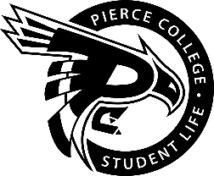
Associated Students of Pierce College Fort Steilacoom (ASPCFS)
Student Government
Meeting Agenda

Location: Zoom

Date: January 19th, 2021

Time: 12:00 p.m. – 1:00 p.m.

Agenda Details:
- Call to Order:
- Pledge of Allegiance:
- Roll Call:
- Establishment of Quorum:
- Changes to the Agenda:
- Approval of Minutes:
- President
Jasmeet Chahal
- Vice President
Khadija Abdi
- Administrative Senator
Ruyi Wan
- Legislative senator
Justin Tran
- Clubs & Organizations Senator:
Jinya Jiang
- Engagement Senator:
Bonnie Bui
- Student & Cultural Affairs Senator:
Vanessa Primer
- Activities Board Representative:
Dennis Johnson
- Old Business: There is no old business.
- New Business: There is no new business.
- Open Forum:
- Announcements:
- Adjournment:

